System Administration & Maintenance

Library Management System

Member: Celestre, Lin bil Subito, Michael Duarong, Audrey
Silvano, Lord Aldren

Course & Section: BSIT - 3208 IM Professor: Patrick David B. Lim, LPT

Submitted: May.17,2025

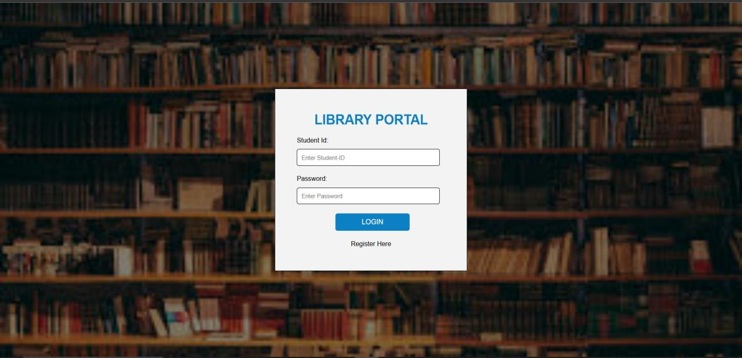

LOGIN UI
Purpose: The main purpose of this screen is to authenticate users specifically students and grant them access to a digital library management system.
Components:
- Student ID Field
- Password Field
- Login Button
- “Register Here” link (for new users)

Functionality:
- User Authentication:
  - Students input their Student ID and Password to log in.
  - The system likely verifies these credentials against a database.
- Access Control:
  - Only registered users can proceed to the portal where they might view or manage book borrowings, returns, reservations, etc.
- Registration Option:
  - The "Register Here" link suggests new users can create an account, likely redirecting them to a registration form.

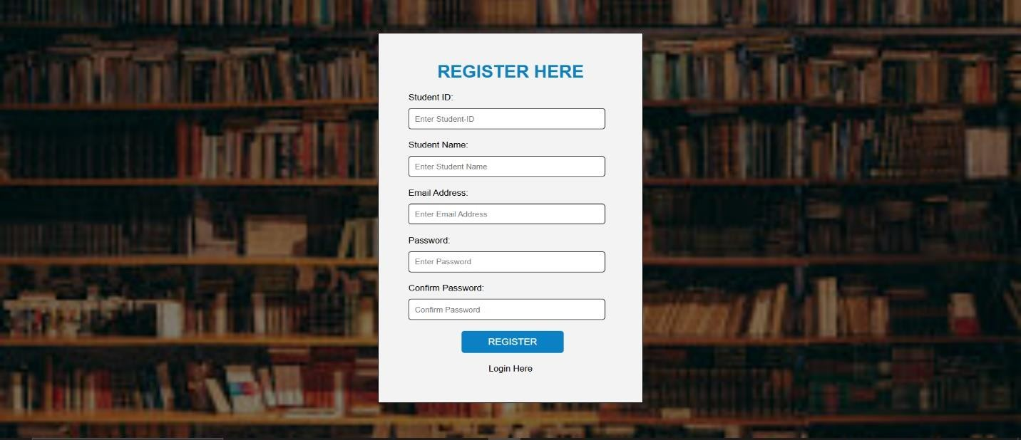

REGISTRATION UI
Purpose: To allow new users (students) to create an account in the library system so they can later log in, search for books, borrow materials, and manage their library activities.
Components:
  - Registration form Fields (Student ID, Student Name, Student Email Address, Password, Confirm Password)
  - Register Button
  - Login Here (link to login page)

Functionality:
- Input Fields for User Details:
  - “Student ID” Unique identifier, likely linked to their academic profile.
  - “Student Name” For identification and personalization.
  - “Email Address” Used for notifications, password resets, or account verification.
  - ” Password & Confirm Password” To securely set login credentials.
- Validation Expected:
  - Matching passwords, Valid email format, Unique Student ID and Possibly password strength checks (though not visible in the UI).
- Action Buttons:
  - REGISTER: Submits the form to create the account.
  - Login Here: Navigates users back to the login page if they already have an account.


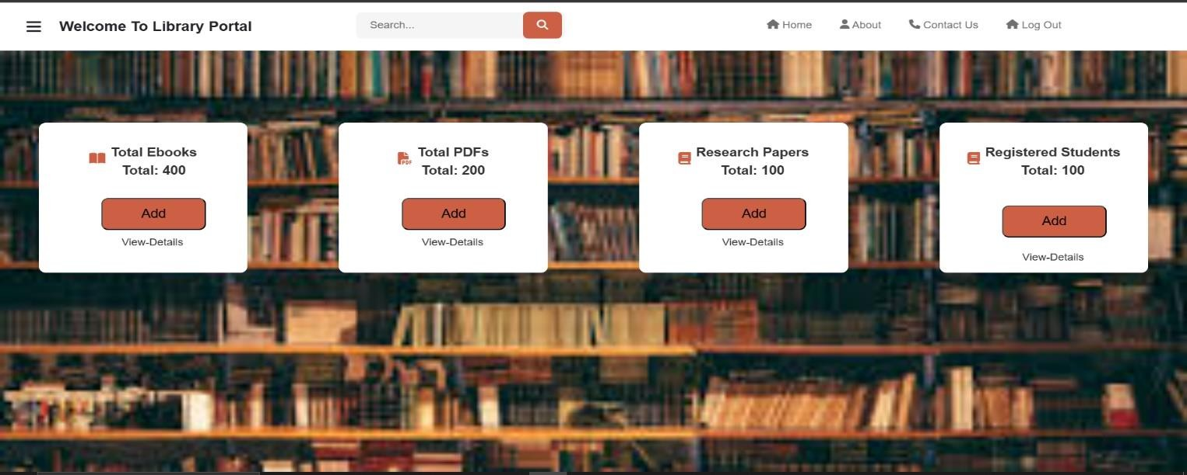


DASHBOARD UI
Purpose: This portal is designed to manage and provide access to various digital library resources and track registered users (students). It likely serves as an admin or staff interface for managing content in an academic or institutional digital library.
Components:
  - Menu Icon (Hamburger or 3 lines Menu (Top left))
  - Site Title “Welcome To Library Portal”.
  - Search Bar (Centered with a search icon)
  - Navigation Links (Home, About, Contact Us (with phone icon) and Log Out (with lock/logout icon))
  - Cards (Icons and total of Ebooks, PDFs, Research Papers and Registered Students (Add Button and View Details link))
Functionality:
Each card in the dashboard shows a summary and has options to manage different resources:
- Total Ebooks:
  - Displays a count of books
  - Add – likely to upload or add new ebooks.
  - View Details – likely shows a list or database of all ebooks.
- Total PDFs:
  - Shows count of PDFs stored.
  - Functions: Add new PDFs and View Details.
- Research Papers:
  - Lists of count research papers.
  - Same functionalities: Add and View Details.
- Registered Students:
  - Indicates the count of users registered.
  - Manage users with Add and View Details options.




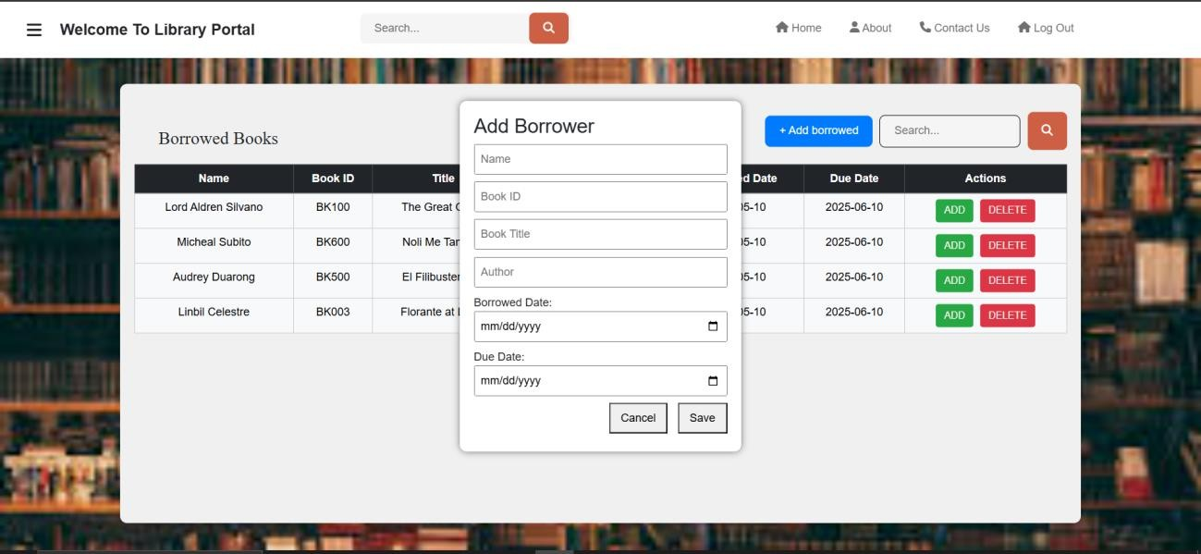

ADD FORM UI
Purpose: To allow library staff to add new borrowers to the library's system. This involves
recording the borrower's name and the details of the book they are borrowing: book ID, title, author, and due date.

Components:
- Add form Fields (Name, Borrower iBook Title, Author,Borrow Date, Borrow Return)
- Cancel Button
- Save Button

Functionality:
- Input Fields of User Information
  - “Name” For the borrower's name.
  - “Book ID” For the book's identification number.
  - “Title” For the book's title.
  - “Author” For the book's author.
  - “Date” There are two date fields, presumably for borrowing and due dates.
- Action Buttons:
  - Cancel Button: to cancel the addition of a borrower.
  - Save Button: to save the new borrower information.


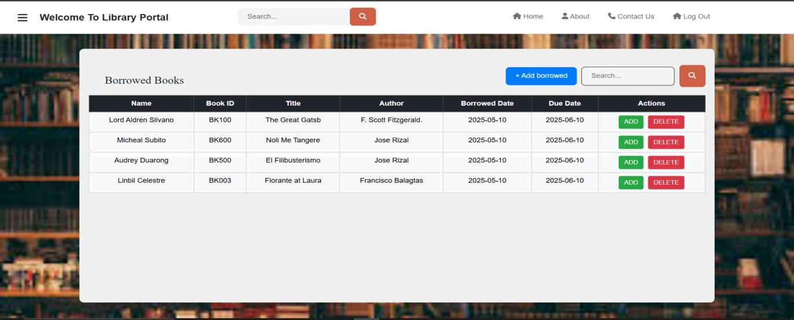


VIEW LIST BORROWED BOOKS UI
Purpose: To display and manage a list of borrowed books by users. It allows library staff or system users to view, add, or delete book borrowing records efficiently.
Components:

- Section Title ("Borrowed Books" heading)
- Tables
- Columns (Name, Book ID, Title, Author, Borrowed Date, Due Date and Actions)
- Rows (Each row represents one borrowed book record)
- Buttons ("+ Add Borrowed" button (blue), "ADD" button (green, per row) and "DELETE" button (red, per row))

Functionality:

- Display Borrowed Books:

  - Shows a list of all borrowed books with detailed information per borrower.

- Add Borrowed Record:

  - The "+ Add Borrowed" button allows users to input new borrowing records.

- Search Records:

  - The search bar allows users to filter the table based on input text (e.g., borrower's name, book title).

- Manage Individual Records:

  - ADD button: Likely used to renew a book, extend a due date, or increment quantity (based on system rules).

  - DELETE button: Removes the corresponding borrowing record from the system




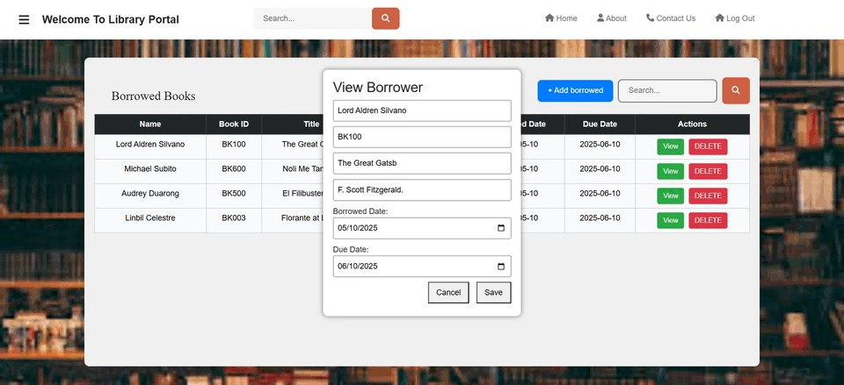

VIEW BUTTON UI
Purpose: To allow the admins to see and view detailed information without editing and manipulating the data.

Components:
  - View Borrower Information
    - Name
    - Book ID
    - Book Title
    - Author
    - Borrowed Date
    - Due Date
    - Buttons (Save & Cancel)

Functionality:
- View Borrower
  - Shows the list of information per name
- Save
  - The save button help the borrower to save the selected information
- Cancel
  - The cancel button help the viewer or admins to exit from the View Button UI


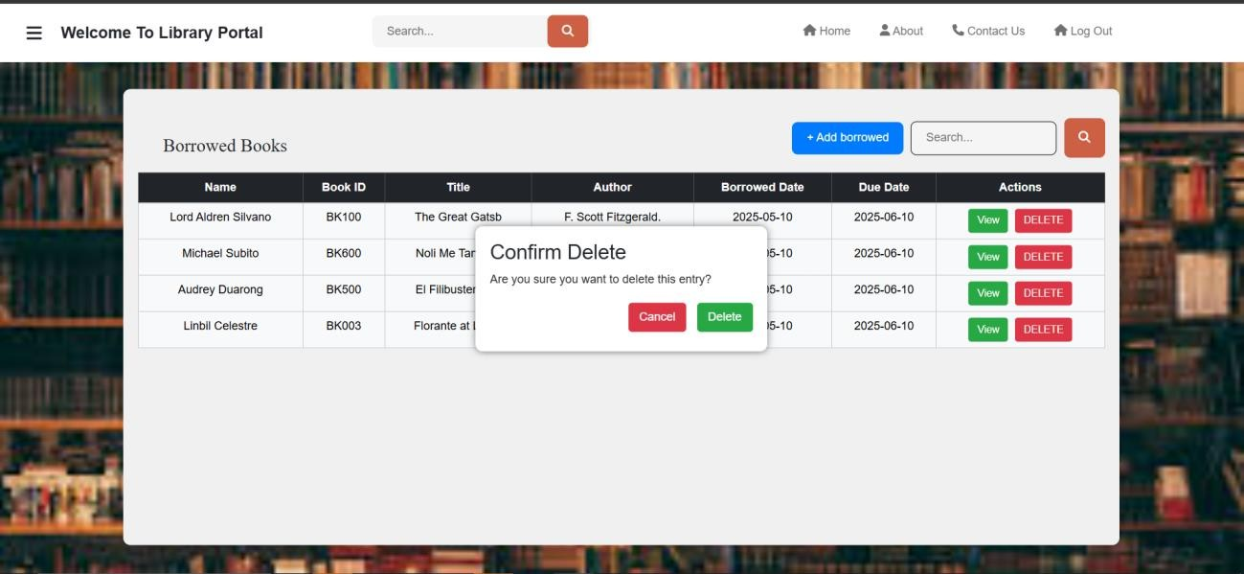


DELETE BUTTON UI
Purpose: The purpose of the delete button is to allow the user to erase or remove the incorrect information they entered.

Components:
  - Confirm delete
    - Confirmation dialog
      - Delete
      - Cancel

Functionality:
- Confirm Delete
  - The delete button allows users to remove incorrect information they have entered, helping prevent errors or accidental data retention
- Confirmation dialog
  - Delete
    - It allows the user or the admin permanently delete mistakes or unwanted data
  - Cancel
    - It allows the user or admin to stop ongoing process without changing the data


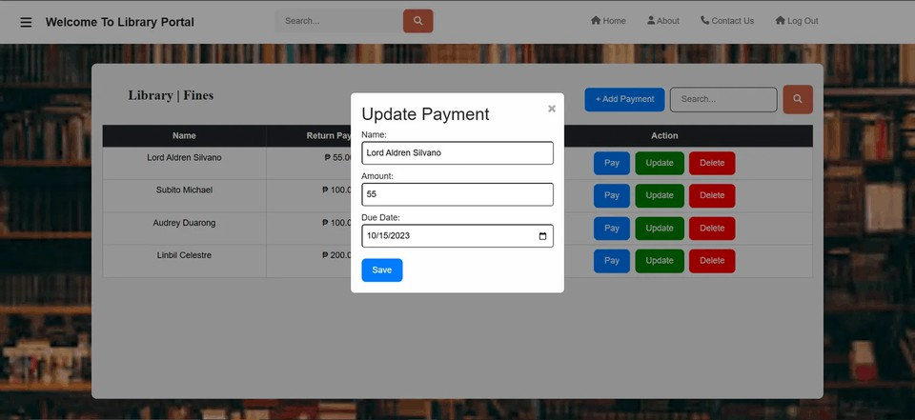


UPDATE BUTTON UI
Purpose: The purpose of the Update button is to allow the user to save changes that they manipulated or edited

Components:
  - Update Payment
    - Name
    - Amount
    - Due Date
  - Save

Functionality:
- Update Payment
  - Name
    - It allows the admin to know who will be paying
  - Amount
    - It allows the admin to view the exact amount of the user’s needed to pay for
  - Due Date
    - It enables the admin to see the exact payment due date
- Save
  - It allows the admin to save the payment record either after making modifications to the data or simply after viewing the record without making any changes




MAINTENANCE
Preventive Maintenance:
- User Authentication Checks
  - Regularly verify the login mechanism to ensure credentials are validated securely.
  - Periodic password policy updates (enforce complexity, expiration).

Database Health Monitoring
  - Schedule backups of user records, book inventory, and borrowing logs.
  - Run integrity checks to avoid data corruption.

UI/UX Testing
  - Routine tests on all UIs (Login, Registration, Dashboard, etc.) to ensure no elements break after updates.
  - Mobile responsiveness and browser compatibility testing.

Security Audits
  - Periodically review access controls.
  - Patch known security vulnerabilities in code or frameworks used.

Storage Management
  - Monitor the size and performance of the system’s file storage (for PDFs, ebooks, research papers).

Performance Optimization
  - Optimize query performance on dashboards and borrowing records.
  - Load testing to prevent slowdowns during peak access times.

Corrective Maintenance:
- Fixing Login Errors
  - Address issues where users can't log in due to incorrect credentials validation or session timeouts.




Broken Registration Forms
  - Correct form submission issues like unresponsive "Register" buttons or failed validations.

Dashboard Malfunctions
  - Fix broken count displays (total ebooks not updating).
  - Correct malfunctioning add/view buttons.

Add Form Issues
  - Resolve data not saving due to backend/database connection errors.
  - Address incorrect input validation.

View/Edit/Delete Bugs
  - Fix buttons that do not trigger the correct action (delete not working, save not storing updated data).
  - Repair broken confirmation dialogs.

Display Problems
  - Correct layout issues or misalignment on various screen sizes.

Search Function Errors
  - Debug and correct search bars not returning results or crashing on specific input.

